- Execute the example 'Time for action - Quickstart AJAX' on page 23 in the book 'AJAX and PHP: Building Modern Web Applications'.

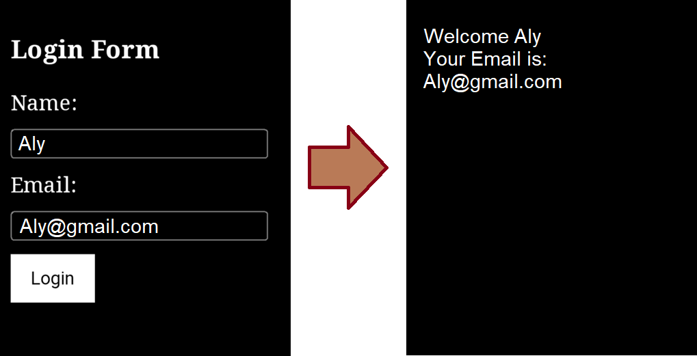
- Create a form using HTML, PHP, and CSS that includes fields for the user's name and email only. Like the following example.

